**Experiment-1.1**

**Student Name**: Sanchit Singal **UID**: 21BCS1569

**Branch**: BE-CSE **Section/Group:** 606_B

**Semester**: 6TH **Date of Performance:**16/01/2024

**Subject Name:** Project Based learning with Java **Subject Code:** 21CSH-319

1. **Aim:** Create an application to save the employee information using arrays.
2. **Objective:** Given the following table containing information about employees of an organization, develop a small java application, which accepts employee id from the command prompt and displays the details
3. **Algorithm:**
4. **Initialize Employee Data:** Create an array or list to store employee details, including employee number, name, department, designation code, and salary components (basic, HRA, IT).
5. **Input Employee ID:** Accept an employee ID from the command line.
6. **Search for Employee:** Iterate through the array or list to find the employee matching the given ID.
7. **Calculate Salary:** If the employee is found, determine their designation and DA (Dearness Allowance) using a switch-case statement based on the designation code.

Calculate the salary using the formula: Basic + HRA + DA - IT.

1. **Display Employee Details:** Display the employee's details, including employee number, name, department, designation, and calculated salary.
2. **Handle Not Found Case:** If the employee ID does not match any in the array or list, display a message indicating the employee is not found.
3. **Code:**

import java.util.Scanner;

class desigDetails {

public char desig_code;

public String designation;

public int da;

desigDetails(char desig_code, String designation, int da) {

this.desig_code = desig_code;

this.designation = designation;

this.da = da;

}

};

class employee {

public int employee_id;

public String employee_name;

public String join_date;

public char desig_code;

public String department;

public int basic;

public int hra;

public int it;

employee(int employee_id, String employee_name, String join_Date, char desig_code, String department, int basic,

int hra, int it) {

this.employee_id = employee_id;

this.employee_name = employee_name;

this.join_date = join_Date;

this.desig_code = desig_code;

this.department = department;

this.basic = basic;

this.hra = hra;

this.it = it;

}

};

public class exp {

public static void main(String[] args) {

desigDetails e = new desigDetails('e', "Engineer", 20000);

desigDetails c = new desigDetails('c', "Consultant", 32000);

desigDetails k = new desigDetails('k', "Clerk", 12000);

desigDetails r = new desigDetails('r', "Receptionist", 15000);

desigDetails m = new desigDetails('m', "Manager", 40000);

desigDetails[] desig_details_array = { e, c, k, r, m };

employee emp1 = new employee(1569, "Sanchit", "01/01/2001", 'e', "Engg", 50000, 100000, 1000);

employee emp2 = new employee(7727, "Arihant", "01/01/2001", 'e', "Engg", 40000, 1000, 1000);

employee[] employee_array = { emp1, emp2 };

Scanner sc = new Scanner(System.in);

while (true) {

int temp;

System.out.println("Do you want to look for employee information? ");

System.out.print("Enter 1 to look for information and enter 0 to stop: ");

temp = sc.nextInt();

if (temp == 0) {

break;

}

System.out.println();

System.out.print("Enter employee id: ");

int id = sc.nextInt();

boolean emp_found = false;

for (employee emp : employee_array) {

if (emp.employee_id == id) {

int salary = emp.basic + emp.hra - emp.it;

String designation = "";

char desig_code = emp.desig_code;

for (desigDetails d : desig_details_array) {

if (d.desig_code == desig_code) {

salary += d.da;

designation = d.designation;

}

}

emp_found = true;

System.out.println("id: " + emp.employee_id);

System.out.println("Name: " + emp.employee_name);

System.out.println("Department: " + emp.department);

System.out.println("Designation: " + designation);

System.out.println("Salary: " + salary);

System.out.println();

break;

}

}

if (!emp_found) {

System.out.println("Employee Not Found");

System.out.println();

}

}

sc.close();

}

}

1. **Output:**

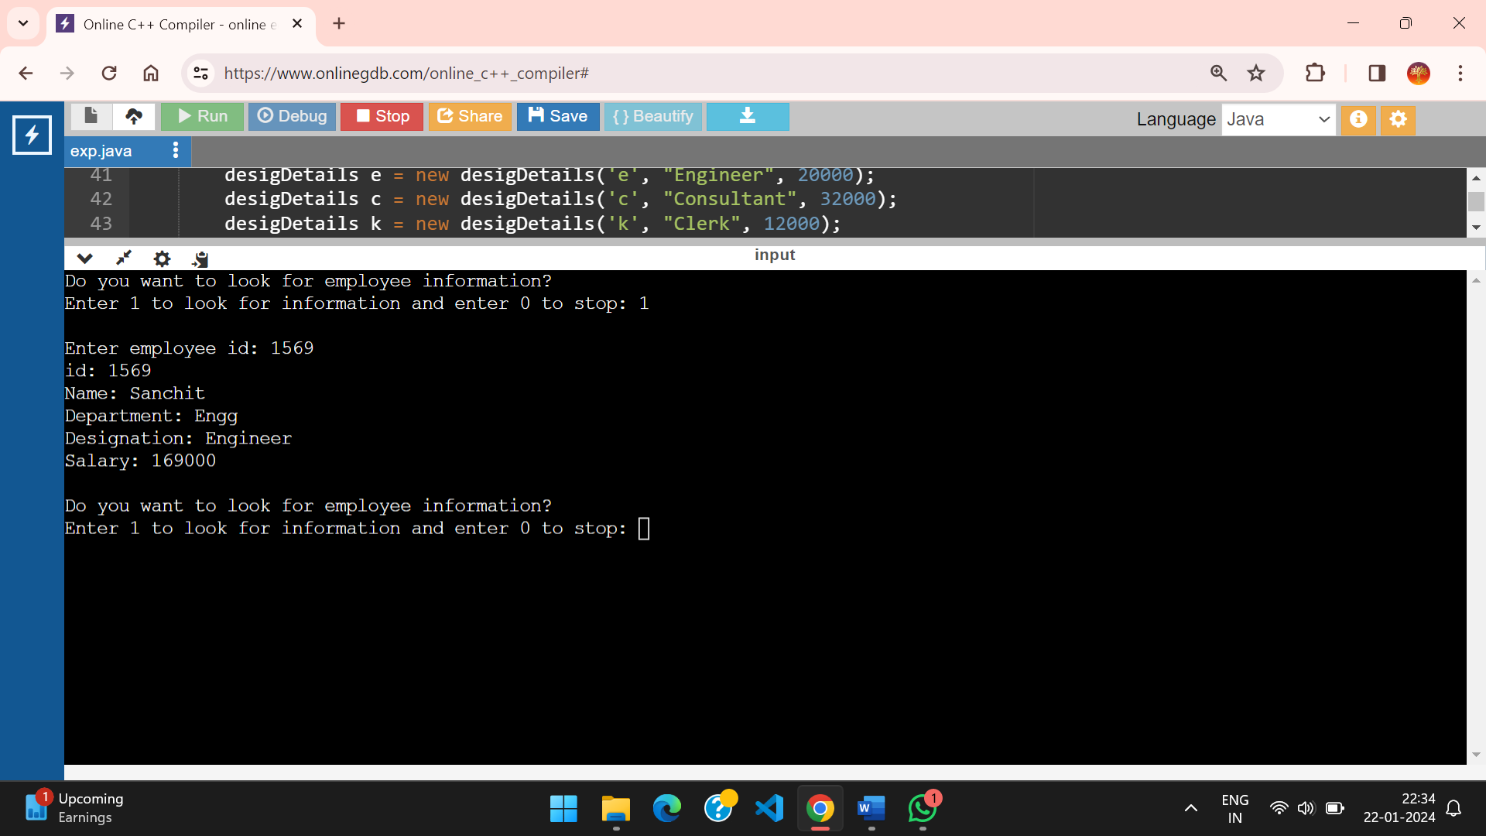

1. **Learning Outcomes:**

1) Array of Employee object to store multiple employ Information

2) Oops concept

3) Switch Statements